高性能集群搭建指南（三） - 软件环境

2017-05-15 22:05:49

## 一、软件环境

### 1. Intel Parallel Stdio

Intel Parallel Stido 内含 Compilers and Libraries, vtune amplifier, inspector, advisor 等。

Compilers and Libraries 包括 C, C++, Fortran编译器和 MKL，MPI库。  
VTune amplifier 是用来分析并行程序性能的工具。

#### 1.1 软件包和序列号

在 Intel 官网中可以申请30天注册版本： <https://software.intel.com/en-us/intel-parallel-studio-xe>

Intel 为学生提供了免费的序列号： <https://software.intel.com/en-us/qualify-for-free-software/student>

#### 1.2 安装 Parallel Stdio

基本全部按回车就行，以下是安装时的记录。

--------------------------------------------------------------------------------  
Initializing, please wait...  
Step 1 of 6 | Welcome  
--------------------------------------------------------------------------------  
Welcome to the Intel(R) Parallel Studio XE 2017 Update 4 for Linux* setup program.  
--------------------------------------------------------------------------------  
--------------------------------------------------------------------------------  
  
  
You will complete the steps below during setup process:  
Step 1 : Welcome  
Step 2 : License agreement  
Step 3 : License activation  
Step 4 : Options  
Step 5 : Installation  
Step 6 : Complete  
  
--------------------------------------------------------------------------------  
Press "Enter" key to continue or "q" to quit: #回车  
  
  
  
  
Step 2 of 6 | License agreement  
--------------------------------------------------------------------------------  
To continue with the installation of this product you are required to accept   
the terms and conditions of the End User License Agreement (EULA). The EULA   
is displayed using the 'more' utility. Press the spacebar to advance to the   
next page or enter 'q' to skip to the end. After reading the EULA, you must   
enter 'accept' to continue the installation or 'decline' to return to the   
previous menu.  
--------------------------------------------------------------------------------  
  
....这里会有一大堆的用户协议，翻到最底下...  
  
  
Document Title and Version: End User License Agreement for the Intel(R) Software  
Development Products (Version March 2016)  
   
* Other names and brands may be claimed as the property of others  
--------------------------------------------------------------------------------  
Type "accept" to continue or "decline" to go back to the previous menu: #accept  
  
  
  
--------------------------------------------------------------------------------  
Checking the prerequisites. It can take several minutes. Please wait...  
Step 2 of 6 | Prerequisites > Missing Optional Prerequisite(s)  
--------------------------------------------------------------------------------  
--------------------------------------------------------------------------------  
There are one or more optional unresolved issues. It is highly recommended to  
resolve them all before you continue. You can fix them without exiting the setup  
program and re-check. Or you can exit the setup program, fix them and run the  
setup program again.  
--------------------------------------------------------------------------------  
Missing optional prerequisites  
-- Driver is already loaded.  
--------------------------------------------------------------------------------  
1. Skip missing optional prerequisites [default]  
2. Show the detailed info about issue(s)  
3. Re-check the prerequisites  
  
h. Help  
b. Back to the previous menu  
q. Quit  
--------------------------------------------------------------------------------  
Please type a selection or press "Enter" to accept default choice [1]: #1 跳过缺少可选的先决条件[默认]  
  
  
  
  
  
Step 3 of 6 | License activation  
--------------------------------------------------------------------------------  
If you have purchased this product and have the serial number and a connection  
to the internet you can choose to activate the product at this time.  
Alternatively, you can choose to evaluate the product or defer activation by  
choosing the evaluate option. Evaluation software will time out in about one  
month. You can also use license file or Intel(R) Software License Manager.  
--------------------------------------------------------------------------------  
1. Use existing license [default]  
2. I want to activate my product using a serial number  
3. I want to evaluate Intel(R) Parallel Studio XE 2017 Update 4 Cluster Edition   
for Linux* or activate later (EXPIRED)  
4. I want to activate by using a license file, or by using Intel(R) Software  
License Manager  
  
h. Help  
b. Back to the previous menu  
q. Quit  
--------------------------------------------------------------------------------  
Please type a selection or press "Enter" to accept default choice [1]: #3 输入序列号激活，用之前提到的学生免费的序列号；没有序列号的话选使用也可以。  
Please type your serial number (the format is XXXX-XXXXXXXX): #2HWS-VWKM5BRR 这是一个可用的序列号，不行的话再申请一个  
--------------------------------------------------------------------------------  
Checking serial number...  
--------------------------------------------------------------------------------  
Activation completed successfully.  
--------------------------------------------------------------------------------  
Press "Enter" key to continue: #回车  
  
  
  
  
  
Step 4 of 6 | Options > Configure Cluster Installation  
--------------------------------------------------------------------------------  
This product can be installed on cluster nodes.  
--------------------------------------------------------------------------------  
1. Finish configuring installation target [default]  
  
2. Installation target [ Current system only ]  
  
h. Help  
b. Back to the previous menu  
q. Quit  
--------------------------------------------------------------------------------  
Please type a selection or press "Enter" to accept default choice [1]: #1 完成配置安装目标[默认]  
  
  
  
Step 4 of 6 | Options > Pre-install Summary  
--------------------------------------------------------------------------------  
Install location:  
 /opt/intel  
  
Component(s) selected:  
 Intel(R) Trace Analyzer and Collector 2017 Update 3 585MB  
 Intel(R) Trace Analyzer for Intel(R) 64 Architecture   
 Intel(R) Trace Collector for Intel(R) 64 Architecture   
 Intel(R) Trace Collector for Intel(R) Many Integrated Core Architecture   
  
 Intel(R) Cluster Checker 2017 Update 2 179MB  
 Cluster Checker common files   
 Cluster Checker Analyzer   
 Cluster Checker Collector   
  
 Intel(R) VTune(TM) Amplifier XE 2017 Update 3 1.2GB  
 Command line interface   
 Sampling Driver kit   
 Graphical user interface   
  
 Intel(R) Inspector 2017 Update 3 361MB  
 Command line interface   
 Graphical user interface   
  
 Intel(R) Advisor 2017 Update 3 714MB  
 Command line interface   
 Graphical user interface   
  
 Intel(R) C++ Compiler 17.0 Update 4 603MB  
 Intel C++ Compiler   
  
 Intel(R) Fortran Compiler 17.0 Update 4 608MB  
 Intel Fortran Compiler   
  
 Intel(R) Math Kernel Library 2017 Update 3 for C/C++ 2.9GB  
 Intel MKL core libraries for C/C++   
 Intel(R) Xeon Phi(TM) coprocessor support for C/C++   
 Cluster support for C/C++   
 Intel TBB threading support   
 GNU* C/C++ compiler support   
  
 Intel(R) Math Kernel Library 2017 Update 3 for Fortran 3.0GB  
 Intel MKL core libraries for Fortran   
 Intel(R) Xeon Phi(TM) coprocessor support for Fortran   
 Cluster support for Fortran   
 GNU* Fortran compiler support   
 Fortran 95 interfaces for BLAS and LAPACK   
  
 Intel(R) Integrated Performance Primitives 2017 Update 3 2.7GB  
 Intel IPP single-threaded libraries: General package   
  
 Intel(R) Threading Building Blocks 2017 Update 6 100MB  
 Intel TBB   
  
 Intel(R) Data Analytics Acceleration Library 2017 Update 3 3.4GB  
 Intel(R) Data Analytics Acceleration Library 2017 Update 3   
  
 Intel(R) MPI Library 2017 Update 3 1.0GB  
 Intel MPI Benchmarks 2017 Update 2   
 Intel MPI Library for applications running on Intel(R) 64 Architecture   
 Intel MPI Library for applications running on Intel(R) Many Integrated   
Core Architecture  
  
 Intel(R) Debugger for Heterogeneous Compute 2017 Update 4 622MB  
 GNU* GDB 7.6 and ELFDWARF library   
  
 GNU* GDB 7.10 95MB  
 GNU* GDB 7.10 on Intel(R) 64   
  
 Intel(R) Debugger for Intel(R) MIC Architecture 2017 Update 4 135MB  
 GNU* GDB 7.8   
 GDB Eclipse* Integration   
  
Install space required: 14.0GB  
  
Driver parameters:  
 Sampling driver install type: Driver will be built  
 Load drivers: yes  
 Reload automatically at reboot: yes  
 Per-user collection mode: no  
 Drivers will be accessible to everyone on this system. To restrict access,  
 select Customize Installation > Change advanced options > Drivers are accessible to  
 and set group access.  
  
Installation target:  
 Install on the current system only  
  
--------------------------------------------------------------------------------  
1. Start installation Now [default]  
2. Customize installation  
  
h. Help  
b. Back to the previous menu  
q. Quit  
--------------------------------------------------------------------------------  
Please type a selection or press "Enter" to accept default choice [1]: #1 开始安装[默认]  
  
--------------------------------------------------------------------------------  
Checking the prerequisites. It can take several minutes. Please wait...  
  
  
  
  
  
Step 4 of 6 | Prerequisites > Missing Optional Prerequisite(s)  
--------------------------------------------------------------------------------  
--------------------------------------------------------------------------------  
There are one or more optional unresolved issues. It is highly recommended to  
resolve them all before you continue. You can fix them without exiting the setup  
program and re-check. Or you can exit the setup program, fix them and run the  
setup program again.  
--------------------------------------------------------------------------------  
Missing optional prerequisites  
-- 32-bit libraries not found  
--------------------------------------------------------------------------------  
1. Skip missing optional prerequisites [default]  
2. Show the detailed info about issue(s)  
3. Re-check the prerequisites  
  
h. Help  
b. Back to the previous menu  
q. Quit  
--------------------------------------------------------------------------------  
Please type a selection or press "Enter" to accept default choice [1]: #1 跳过缺少的可选条件[默认]  
  
  
  
  
  
Step 5 of 6 | Installation  
--------------------------------------------------------------------------------  
Each component will be installed individually. If you cancel the installation,  
some components might remain on your system. This installation may take several   
minutes, depending on your system and the options you selected.  
--------------------------------------------------------------------------------  
Installing Intel(R) Trace Analyzer for Intel(R) 64 Architecture component... done  
--------------------------------------------------------------------------------  
Installing Intel(R) Trace Collector for Intel(R) 64 Architecture component... done  
--------------------------------------------------------------------------------  
Installing Intel(R) Trace Collector for Intel(R) Many Integrated Core  
Architecture component... done  
--------------------------------------------------------------------------------  
Installing Cluster Checker common files component... done  
--------------------------------------------------------------------------------  
Installing Cluster Checker Analyzer component... done  
--------------------------------------------------------------------------------  
Installing Cluster Checker Collector component... done  
--------------------------------------------------------------------------------  
Installing Command line interface component... done  
--------------------------------------------------------------------------------  
Installing Sampling Driver kit component... done  
--------------------------------------------------------------------------------  
Installing Graphical user interface component... done  
--------------------------------------------------------------------------------  
Installing Command line interface component... done  
--------------------------------------------------------------------------------  
Installing Graphical user interface component... done  
--------------------------------------------------------------------------------  
Installing Command line interface component... done  
--------------------------------------------------------------------------------  
Installing Graphical user interface component... done  
--------------------------------------------------------------------------------  
Installing Intel C++ Compiler for IA-32 component... done  
--------------------------------------------------------------------------------  
Installing Intel C++ Compiler for Intel(R) 64 component... done  
--------------------------------------------------------------------------------  
Installing Intel Fortran Compiler for IA-32 component... done  
--------------------------------------------------------------------------------  
Installing Intel Fortran Compiler for Intel(R) 64 component... done  
--------------------------------------------------------------------------------  
Installing Intel MKL core libraries for C/C++ for IA-32 component... done  
--------------------------------------------------------------------------------  
Installing Intel MKL core libraries for C/C++ for Intel(R) 64 component... done  
--------------------------------------------------------------------------------  
Installing Intel(R) Xeon Phi(TM) coprocessor support for C/C++ component... done  
--------------------------------------------------------------------------------  
Installing Cluster support for C/C++ component... done  
--------------------------------------------------------------------------------  
Installing Intel TBB threading support for IA-32 component... done  
--------------------------------------------------------------------------------  
Installing Intel TBB threading support for Intel(R) 64 component... done  
--------------------------------------------------------------------------------  
Installing GNU* C/C++ compiler support for IA-32 component... done  
--------------------------------------------------------------------------------  
Installing GNU* C/C++ compiler support for Intel(R) 64 component... done  
--------------------------------------------------------------------------------  
Installing Intel MKL core libraries for Fortran for IA-32 component... done  
--------------------------------------------------------------------------------  
Installing Intel MKL core libraries for Fortran for Intel(R) 64 component... done  
--------------------------------------------------------------------------------  
Installing Intel(R) Xeon Phi(TM) coprocessor support for Fortran component... done  
--------------------------------------------------------------------------------  
Installing Cluster support for Fortran component... done  
--------------------------------------------------------------------------------  
Installing GNU* Fortran compiler support for Intel(R) 64 component... done  
--------------------------------------------------------------------------------  
Installing GNU* Fortran compiler support for IA-32 component... done  
--------------------------------------------------------------------------------  
Installing Fortran 95 interfaces for BLAS and LAPACK for IA-32 component... done  
--------------------------------------------------------------------------------  
Installing Fortran 95 interfaces for BLAS and LAPACK for Intel(R) 64  
component... done  
--------------------------------------------------------------------------------  
Installing Intel IPP single-threaded libraries for IA-32: General package  
component... done  
--------------------------------------------------------------------------------  
Installing Intel IPP single-threaded libraries for Intel(R) 64: General package   
component... done  
--------------------------------------------------------------------------------  
Installing Intel TBB component... done  
--------------------------------------------------------------------------------  
Installing Intel DAAL for IA-32 component... done  
--------------------------------------------------------------------------------  
Installing Intel DAAL for Intel(R) 64 component... done  
--------------------------------------------------------------------------------  
Installing Intel MPI Benchmarks 2017 Update 2 component... done  
--------------------------------------------------------------------------------  
Installing Intel MPI Library for applications running on Intel(R) 64  
Architecture component... done  
--------------------------------------------------------------------------------  
Installing Intel MPI Library for applications running on Intel(R) Many  
Integrated Core Architecture component... done  
--------------------------------------------------------------------------------  
Installing GNU* GDB 7.6 and ELFDWARF library component... done  
--------------------------------------------------------------------------------  
Installing GNU* GDB 7.10 on Intel(R) 64 component... done  
--------------------------------------------------------------------------------  
Installing GNU* GDB 7.8 component... done  
--------------------------------------------------------------------------------  
Installing GDB Eclipse* Integration component... done  
--------------------------------------------------------------------------------  
Finalizing product configuration...  
Preparing driver configuration scripts... done  
--------------------------------------------------------------------------------  
Installing drivers. It may take several minutes... done  
--------------------------------------------------------------------------------  
Sampling driver built successfully  
Sampling driver loaded successfully  
Sampling driver boot script installed successfully  
--------------------------------------------------------------------------------  
  
  
  
  
  
Step 6 of 6 | Complete  
--------------------------------------------------------------------------------  
--------------------------------------------------------------------------------  
Thank you for installing Intel(R) Parallel Studio XE 2017 Update 4  
Cluster Edition for Linux*.  
  
If you have not done so already, please register your product with Intel  
Registration Center to create your support account and take full advantage of  
your product purchase.  
  
Your support account gives you access to free product updates and upgrades  
as well as Priority Customer support at the Online Service Center  
https://supporttickets.intel.com.  
  
Click here https://software.intel.com/en-us/python-distribution   
to download Intel(R) Distribution for Python*  
This download will initiate separately. You can proceed with the installation  
screen instructions.  
--------------------------------------------------------------------------------  
Press "Enter" key to quit: #安装完成

#### 1.3 环境变量

Parallel Stdio 有一大堆的动态链接库可执行文件和需要添加到环境变量中，Intel 已经写好了相应的脚本，运行它的脚本即可完成所有环境变量的添加。

我们把它写到 /etc/profile 中，在用户登录时会自动运行该脚本，完成环境变量的添加。

$ echo "source /opt/intel/parallel_studio_xe_2017.4.056/psxevars.sh" >> /etc/profile  
  
$ source /etc/profle   
Intel(R) Parallel Studio XE 2017 Update 4 for Linux*  
Copyright (C) 2009-2017 Intel Corporation. All rights reserved.

可以检验一下

$ echo $PATH  
/usr/local/bin:/opt/intel/vtune_amplifier_xe_2017.3.0.510739/bin64:/opt/intel/compilers_and_libraries_2017.4.196/linux/bin/intel64:/opt/intel/compilers_and_libraries_2017.4.196/linux/mpi/intel64/bin:/opt/intel/debugger_2017/gdb/intel64_mic/bin:/opt/intel/vtune_amplifier_xe_2017.2.0.499904/bin64:/opt/intel/compilers_and_libraries_2017.4.196/linux/bin/intel64:/opt/intel/compilers_and_libraries_2017.4.196/linux/mpi/intel64/bin:/opt/intel/debugger_2017/gdb/intel64_mic/bin:/usr/local/sbin:/usr/local/bin:/usr/sbin:/usr/bin:/opt/ibutils/bin:/root/bin  
  
$ echo $LD_LIBRARY_PATH   
/opt/intel/compilers_and_libraries_2017.4.196/linux/compiler/lib/intel64:/opt/intel/compilers_and_libraries_2017.4.196/linux/compiler/lib/intel64_lin:/opt/intel/compilers_and_libraries_2017.4.196/linux/mpi/intel64/lib:/opt/intel/compilers_and_libraries_2017.4.196/linux/mpi/mic/lib:/opt/intel/compilers_and_libraries_2017.4.196/linux/ipp/lib/intel64:/opt/intel/compilers_and_libraries_2017.4.196/linux/compiler/lib/intel64_lin:/opt/intel/compilers_and_libraries_2017.4.196/linux/mkl/lib/intel64_lin:/opt/intel/compilers_and_libraries_2017.4.196/linux/tbb/lib/intel64/gcc4.7:/opt/intel/debugger_2017/iga/lib:/opt/intel/debugger_2017/libipt/intel64/lib:/opt/intel/compilers_and_libraries_2017.4.196/linux/daal/lib/intel64_lin:/opt/intel/compilers_and_libraries_2017.4.196/linux/compiler/lib/intel64:/opt/intel/compilers_and_libraries_2017.4.196/linux/compiler/lib/intel64_lin:/opt/intel/compilers_and_libraries_2017.4.196/linux/mpi/intel64/lib:/opt/intel/compilers_and_libraries_2017.4.196/linux/mpi/mic/lib:/opt/intel/compilers_and_libraries_2017.4.196/linux/ipp/lib/intel64:/opt/intel/compilers_and_libraries_2017.4.196/linux/compiler/lib/intel64_lin:/opt/intel/compilers_and_libraries_2017.4.196/linux/mkl/lib/intel64_lin:/opt/intel/compilers_and_libraries_2017.4.196/linux/tbb/lib/intel64/gcc4.7:/opt/intel/debugger_2017/iga/lib:/opt/intel/debugger_2017/libipt/intel64/lib:/opt/intel/compilers_and_libraries_2017.4.196/linux/daal/lib/intel64_lin:/opt/intel/compilers_and_libraries_2017.4.196/linux/daal/../tbb/lib/intel64_lin/gcc4.4:/usr/local/lib:

source /opt/intel/bin/compilervars.sh intel64 也可以，缺点是未添加VTune的路径。

#### 1.4 VTune 的使用

VTune是Intel开发的一个比较强大的并行程序性能分析工具

* 使用 amplxe-cl 命令可进行性能数据收集和分析

$ amplxe-cl -collect hotspots <需分析的可执行文件>

随后会在当前目录生成分析结果

* 通过 amplxe-gui 查看分析结果

由于需要使用 GUI 界面，故需要转发 X11

如果使用xshell连接服务器，可以转发 X11 到 xmanager中

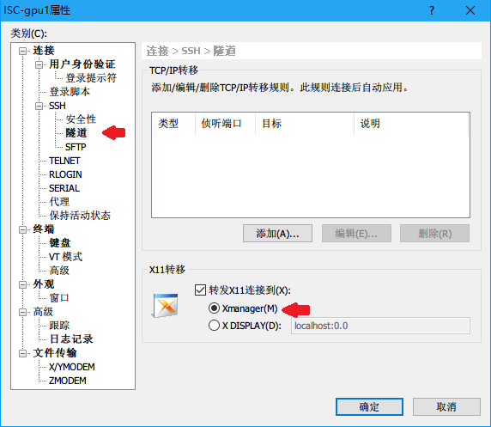

如果使用Linux的 Terminal 链接到服务器，可以通过 -Y 选项来转发X11

$ ssh lq@10.4.14.111 -Y

打开VTune分析界面

$ amplxe-gui

打开结果文件

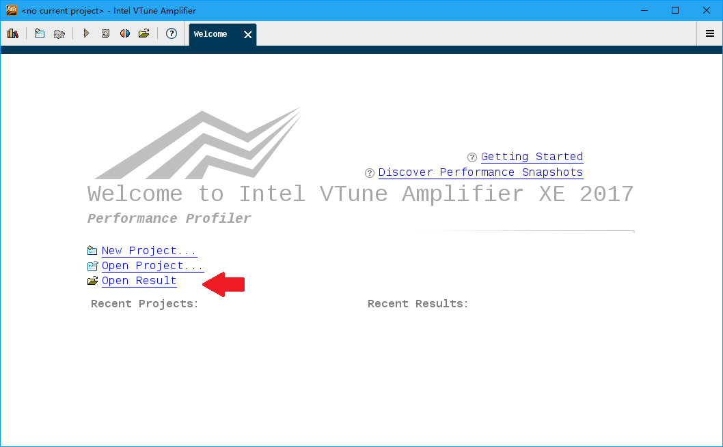

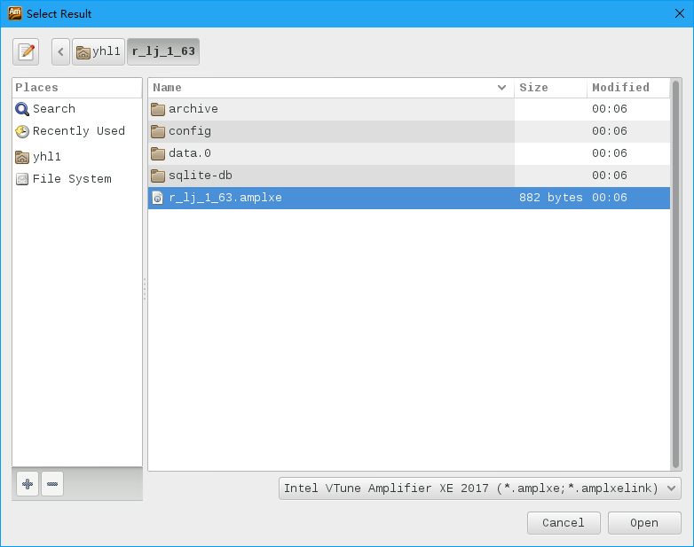

可以看到基本的分析结果

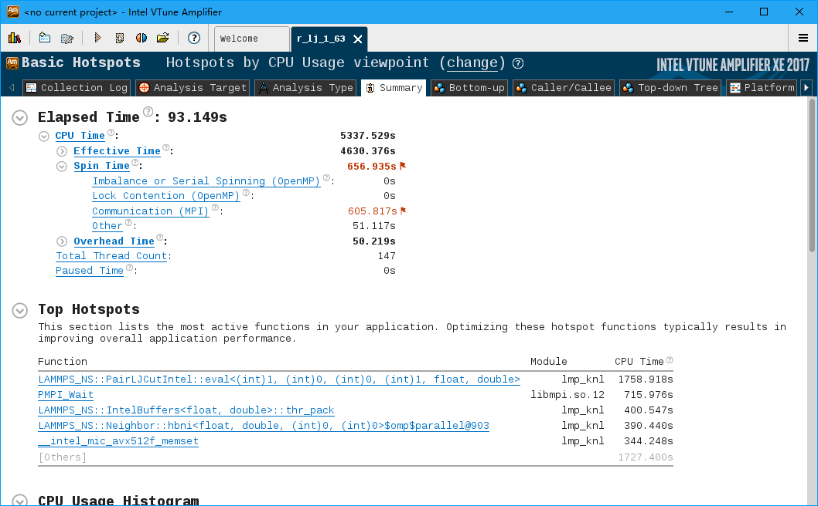

在Bottom-up中可以看到程序的瓶颈

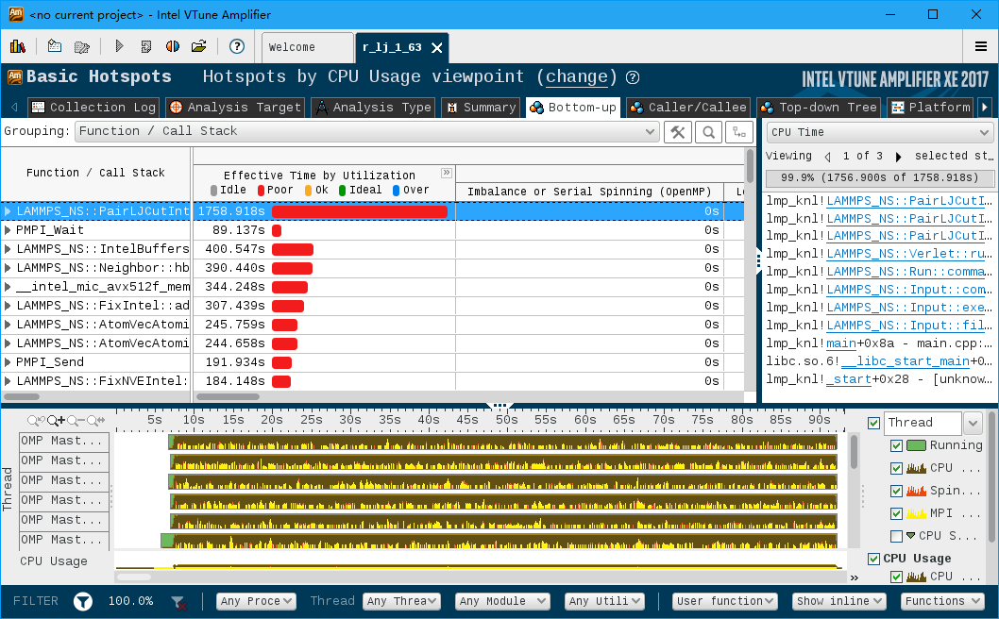

进入热点函数中可以看到各行代码的时间占比

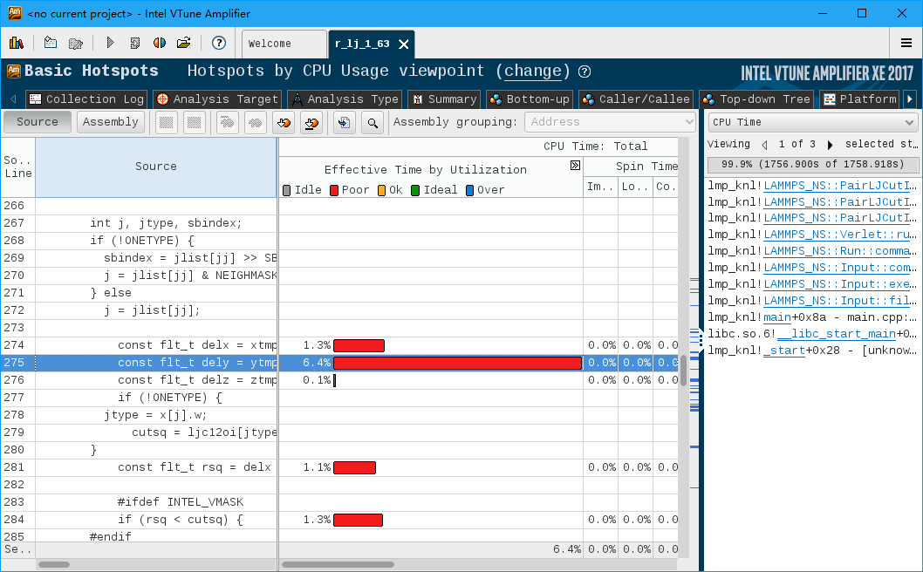

### 2. MPICH MVAPICH openMPI

MPICH 和 MVAPICH 以常规方式源码安装，下载官方源码解压即可。

下载链接如下 ↓  
[MPICH-3.2:http://www.mpich.org/static/downloads/3.2/mpich-3.2.tar.gz](http://www.mpich.org/static/downloads/3.2/mpich-3.2.tar.gz)  
[MVAICH-2.3a:](http://mvapich.cse.ohio-state.edu/download/mvapich/mv2/mvapich2-2.3a.tar.gz) <http://mvapich.cse.ohio-state.edu/download/mvapich/mv2/mvapich2-2.3a.tar.gz> [openMPI-2.1.1https://www.open-mpi.org/software/ompi/v2.1/downloads/openmpi-2.1.1.tar.gz](https://www.open-mpi.org/software/ompi/v2.1/downloads/openmpi-2.1.1.tar.gz)

#### 2.1 安装

$ ./configure --prefix=/opt/<dir_name>  
$ make -j all #开启所有线程进行编译，也可以指定为特定线程数，如 make -j 20  
$ make install #需要权限

#### 2.2 环境变量

最好用过 module 来管理多个版本的mpi

$ export PATH=<TOPdir>/bin:$PATH  
$ export LD_LIBRARY_PATH=<TOPdir>/lib:$LD_LIBRARY_PATH

### 3. cuda 驱动

#### 3.1 查看GPU

$ lspci | grep -i nvidia   
83:00.0 3D controller: NVIDIA Corporation GK210GL [Tesla K80] (rev a1)  
84:00.0 3D controller: NVIDIA Corporation GK210GL [Tesla K80] (rev a1)

#### 3.2 在nvidia开发者社区中下载软件包并安装

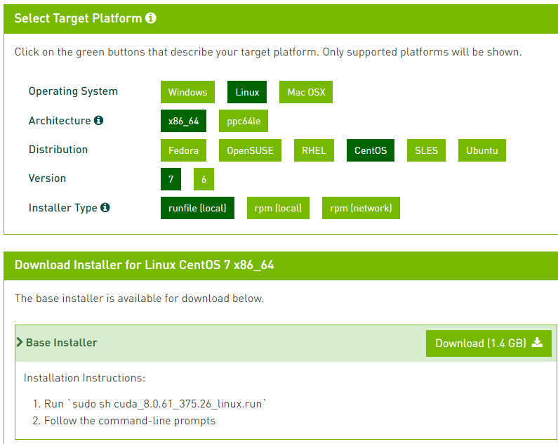

#### 3.3 环境变量

将环境变量添加至 /etc/profile 中

$ export LD_LIBRARY_PATH=/usr/local/cuda-8.0/lib64:$LD_LIBRARY_PATH  
$ export PATH=/usr/local/cuda-8.0/bin:$PATH

#### 3.4 查看GPU使用情况

$ nvidia-smi  
  
Tue May 23 15:02:42 2017   
+-----------------------------------------------------------------------------+  
| NVIDIA-SMI 375.26 Driver Version: 375.26 |  
|-------------------------------+----------------------+----------------------+  
| GPU Name Persistence-M| Bus-Id Disp.A | Volatile Uncorr. ECC |  
| Fan Temp Perf Pwr:Usage/Cap| Memory-Usage | GPU-Util Compute M. |  
|===============================+======================+======================|  
| 0 Tesla K80 Off | 0000:83:00.0 Off | Off |  
| N/A 70C P0 113W / 149W | 3942MiB / 12205MiB | 81% Default |  
+-------------------------------+----------------------+----------------------+  
| 1 Tesla K80 Off | 0000:84:00.0 Off | Off |  
| N/A 58C P0 125W / 149W | 3942MiB / 12205MiB | 80% Default |  
+-------------------------------+----------------------+----------------------+  
   
+-----------------------------------------------------------------------------+  
| Processes: GPU Memory |  
| GPU PID Type Process name Usage |  
|=============================================================================|  
| 0 21271 C ./mini_dft 3940MiB |  
| 1 21272 C ./mini_dft 3940MiB |  
+-----------------------------------------------------------------------------+

### 4. RAPL

RAPL是CPU的功耗控制工具，其通过动态调整CPU频率来控制CPU的最高功率。

#### 4.1 查看CPU功耗信息

$ turbostat -i 1  
  
0.002701 sec  
 CPU Avg_MHz %Busy Bzy_MHz TSC_MHz SMI CPU%c1 CPU%c3 CPU%c6 CPU%c7 CoreTmp PkgTmp Pkg%pc2 Pkg%pc3 Pkg%pc6 PkgWatt RAMWatt PKG_% RAM_%  
 - 89 7.18 1216 2539 0 30.26 3.14 59.42 0.00 43 48 25.74 0.00 0.00 43.50 9.68 0.00 0.00  
 0 98 7.96 1195 2572 0 27.03 0.00 65.01 0.00 38 45 25.28 0.00 0.00 18.40 5.58 0.00 0.00  
 1 119 9.47 1219 2584 0 28.75 0.00 61.78 0.00 41  
 2 145 11.72 1199 2574 0 29.63 12.31 46.35 0.00 40  
 3 105 8.52 1200 2562 0 25.53 10.98 54.96 0.00 43  
 4 95 7.52 1238 2550 0 35.52 0.00 56.97 0.00 41  
 5 65 5.35 1200 2548 0 31.44 4.72 58.49 0.00 37  
 6 66 5.39 1199 2547 0 33.05 3.07 58.49 0.00 38  
 7 74 6.02 1200 2544 0 33.09 1.37 59.52 0.00 40  
 8 74 6.01 1215 2542 0 33.10 3.51 57.39 0.00 38  
 9 100 7.90 1244 2537 0 30.90 1.86 59.34 0.00 38  
 10 72 5.91 1201 2536 0 29.84 0.00 64.25 0.00 40  
 11 69 5.39 1273 2532 0 27.91 0.00 66.70 0.00 39  
 12 91 7.45 1199 2547 0 28.14 12.70 51.71 0.00 38 48 25.78 0.00 0.00 25.11 4.09 0.00 0.00  
 13 66 5.30 1226 2546 0 27.75 10.88 56.06 0.00 41  
 14 71 5.57 1254 2533 0 30.28 0.00 64.15 0.00 41  
 15 70 5.76 1200 2530 0 33.03 0.00 61.21 0.00 43  
 16 92 7.03 1297 2526 0 33.50 2.85 56.62 0.00 39  
 17 67 5.48 1202 2530 0 34.73 5.15 54.64 0.00 42  
 18 77 6.35 1198 2530 0 34.08 3.58 55.99 0.00 41  
 19 64 5.17 1227 2529 0 30.65 1.97 62.22 0.00 43  
 20 64 5.28 1201 2525 0 29.36 0.00 65.37 0.00 41  
 21 74 6.15 1201 2518 0 27.66 0.00 66.19 0.00 40  
 22 63 5.25 1202 2507 0 26.06 0.00 68.68 0.00 40  
 23 248 20.45 1216 2495 0 25.20 0.00 54.35 0.00 39

* Busy_MHZ: CPU忙碌时的平均时钟频率（处于“c0”状态）。
* CPU%c1: CPU处于c1状态的时间占比
* CPU%c3: CPU处于c3状态的时间占比
* CPU%c6: CPU处于c6状态的时间占比
* CPU%c7: CPU处于c7状态的时间占比
* PkgTmp: CPU温度
* PkgWatt: CPU功率
* RAMWatt: 内存功率

#### 4.2 重新编译

* 修改 RaplSetPowerSeprate.c

int main(int argc, char **argv) {  
 int fd1,fd2;  
 int core1=0;  
  
 int core2=12; //@@ lq: core 2 is the first index of second CPU package.(number of one CPU cores) Example: for E5-2680v4 is 14

* 修改RaplPowerLimitDisable.c

fd=open_msr(12); //@@lq modify the core num of one CPU here. Example: for E5-2680v4 is 14.

* 重新编译

$ make clean  
$ make

#### 4.3 设置功率

$ ./RaplSetPowerSeprate 120 120 #设置两个socket的最高功率

$ ./RaplPowerLimitDisable # reset

### 5. 通过modules 管理环境变量

#### 5.1 安装 modules

$ yum install environment-modules -y

#### 5.2 配置文件

示例如下

$ cat mvapich   
  
#%Module1.0  
prepend-path LD_LIBRARY_PATH /opt/mvapich2-2.3a/lib #动态链接库  
prepend-path PATH /opt/mvapich2-2.3a/bin #可执行文件

#### 5.3 加载

$ module use /home/cluster/modules #指定modules配置文件目录  
  
$ module load mpi/mvapich #加载环境变量模块  
$ module list #查看已加载模块  
Currently Loaded Modulefiles:  
1) mpi/mvapich  
  
$ module unload mpi/mvapich #卸载环境变量  
$ module list  
Currently Loaded Modulefiles: